Quality and Its Defining Factors
For our project, we decided to use a wine quality dataset from UC Irvine. We found this dataset to be useful for identifying which factors influence the rating of wine quality (i.e. taste preference) the most. With this information, wine industries can ensure that the best quality Vinho Verde is being produced for consumption and is certified to be safe. In a way, it informs these industries on which qualities of wine are most marketable and popular among consumers while learning about potential areas of improvement in the production of wine. Thus, the question we decided to answer within this project is what variables influence ratings on the quality of the company’s wine the most.

The data was extracted between May 2004 and February 2007 during the certification step by CVRVV and was recorded by iLab for testing. Specifically, red and white wine samples from Portugal were included in the test. Physiochemical and sensory variables were studied and predictors found within the dataset were alcohol, color, density, sugar, pH, sulphates, chlorides, sugar, sulfur dioxide, citric acid, and acidity. We utilized this data in our analysis of the relationship between the response variable, quality, and assessed which variables to consider important.

Starting off, we compressed down the two thousand odd observations in the data set to a total of 300, 150 from the .csv file that represented red wine and 150 from the .csv file that represented white wine. We also considered all 12 variables that were originally in the model. One of these variables was a dummy variable we had added to account for the color of the wine when we combined .csv files (0 for red and 1 for white). All other x variables were continuous, while our y variable was discrete. A basic summary of our raw data is shown below in image 1.

Image 1
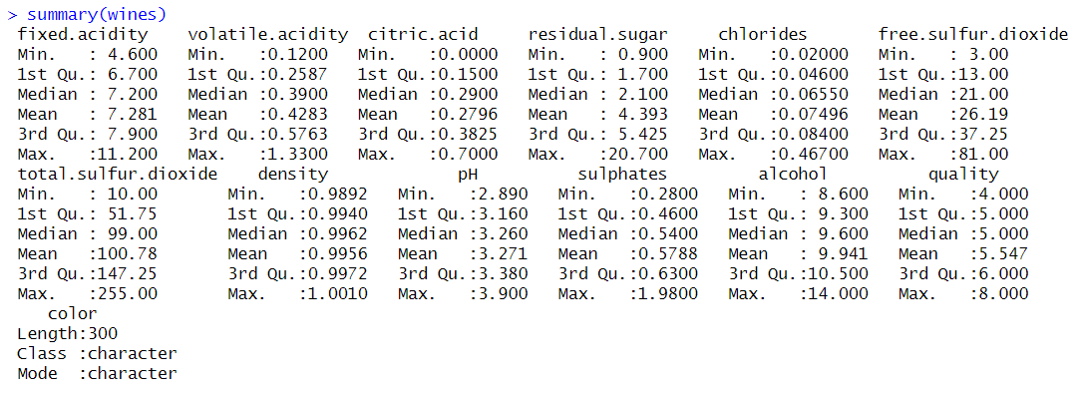
Checking individual distributions of our variables gave us more insight on any variables that may need transformations. Luckily, they mostly looked normally distributed, as demonstrated in image 2. The only variable that seemed to bring up some minor concern for transformation was total sulfur dioxide, which seemed to lack any shape in its distribution (image 3).
Image 2 Image 3
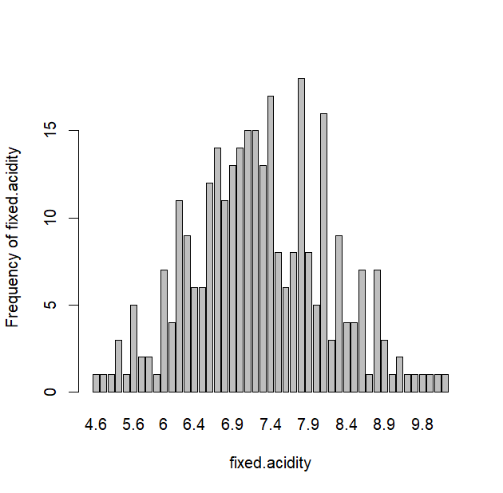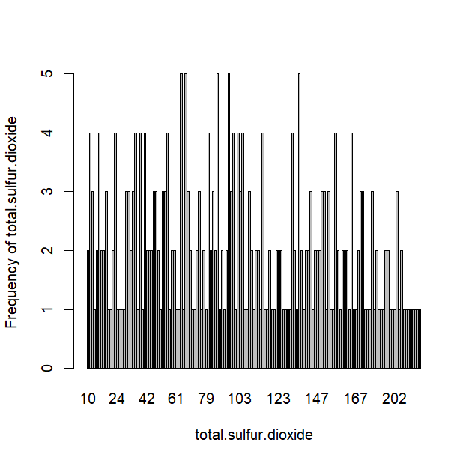
Looking deeper into our variables, we found that this interesting variable also had collinearity issues with free sulfur dioxide, as seen in image 4. Because these variables were closely related, we decided to combine them and fix two issues in one move.

Image 4
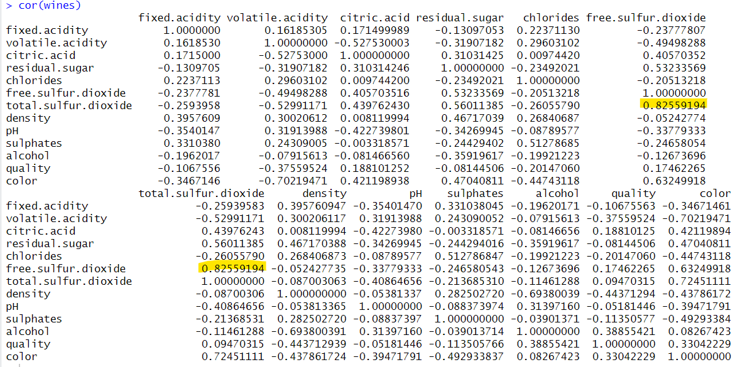
With these two issues resolved, we decided that no transformations were going to be needed to complete out analysis and moved on to selecting our model. First, we conducted an overall F-test to see what variables were insignificant when it came to deciding the quality of red and white wines. The overall F-test failed, telling us that there were variables that existed that had a significant overall regression of wine quality, thus, it was necessary to choose a model selection process that worked as accurately as possible.

We began with a backwards piecewise selection. The results it gave prompted us to delete 3 variables, as shown in image 5. A problem persisted, however, where insignificant variables (which are variables with p – values higher than 0.05) were being kept, so we decided to try our hand with forward piecewise selection (image 6).
Image 5

Image 6
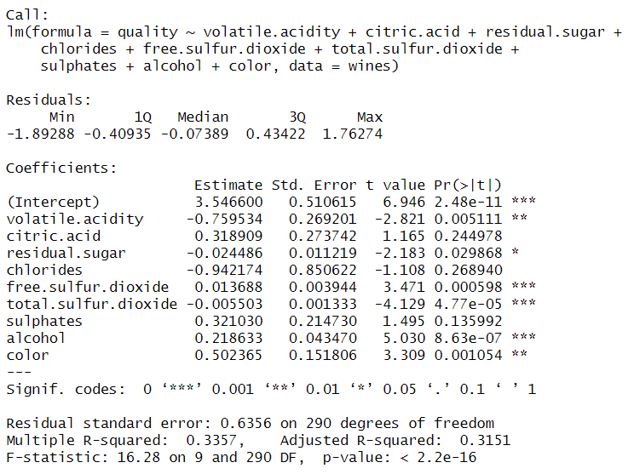

The same instance was seen with this model selection process where variables were taken out but others with insignificant p – values were being kept in (images 7 & 8). With this selection process however, we had the luxury of checking the plots of AIC, adjusted $R^{2}$, and mean squared errors to confirm whether forward selection was correct despite the unusual variable retentions. As confirmed in image 9, the $R^{2}$ values were found to be increasing while the other two predictors were decreasing, which was confirmation that this selection process was accurate.
Image 7
Image 8
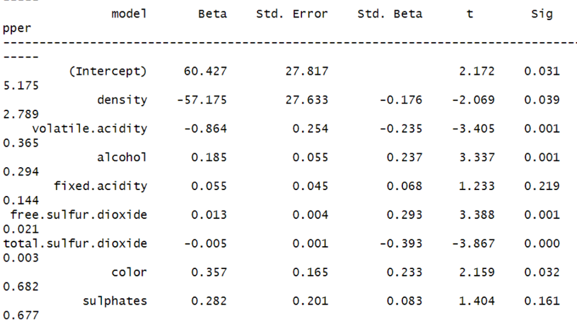
Image 9
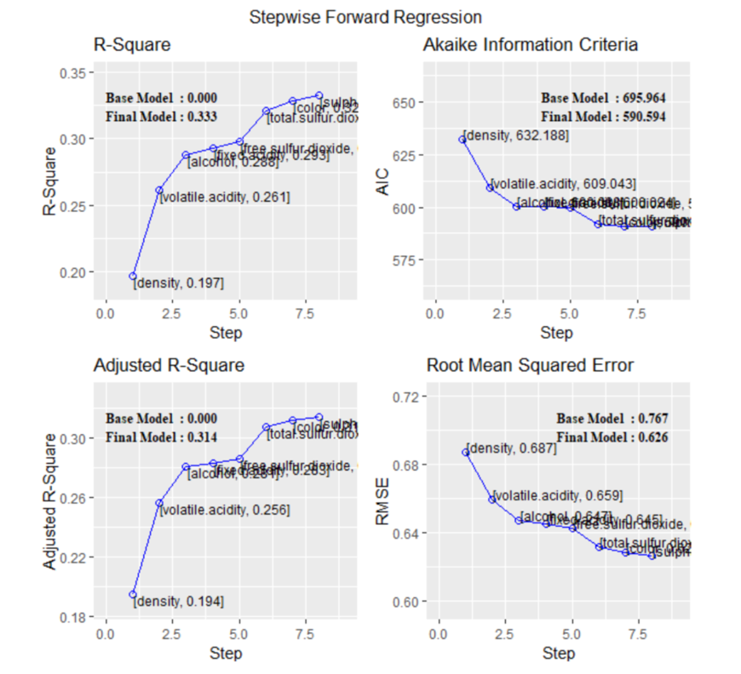
Now that we had an accurate model picked out that informed us of the important variables that affected red and white wine qualities, we had to further ensure that this model didn’t violate any assumptions.

We first ran partial regression plots on the variables to see if we needed to do any transformations on them before we checked the validity of the model. There was a slight curve in the plots for fixed acidity and pH, but for us it wasn’t strong enough evidence to transform them (image 10 & 11).
Image 10
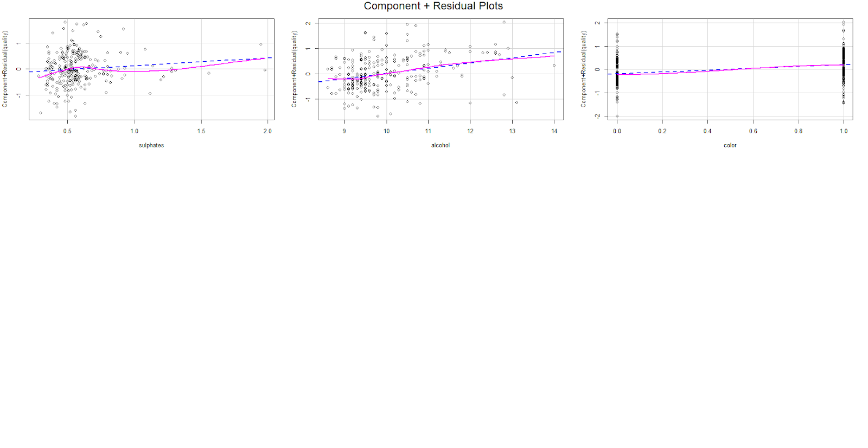

Image 11
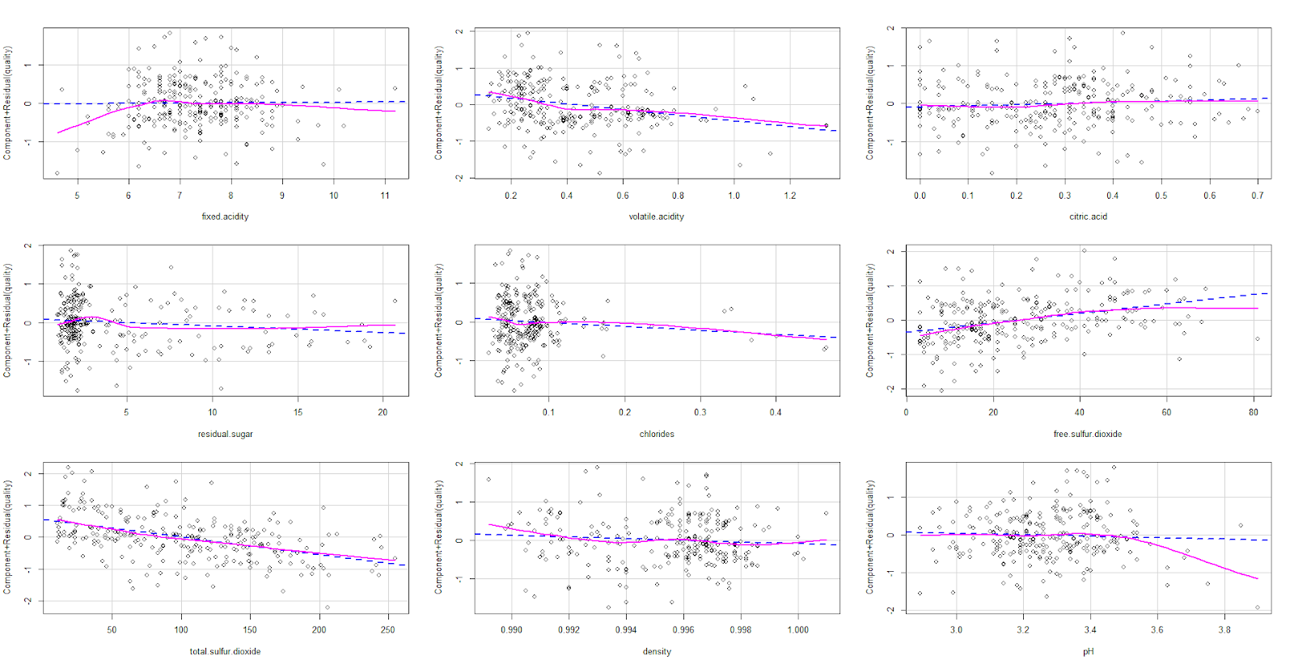
We next looked to verify the linearity and homoscedasticity assumptions by checking the residual vs fitted plots (image 12). Because the data included a discrete variable as the response, the residual plots didn’t look how it would normally when all variables are continuous – as there are only a fixed amount of values that could possibly exist. Thus, we assumed these assumptions weren’t violated.
Image 12
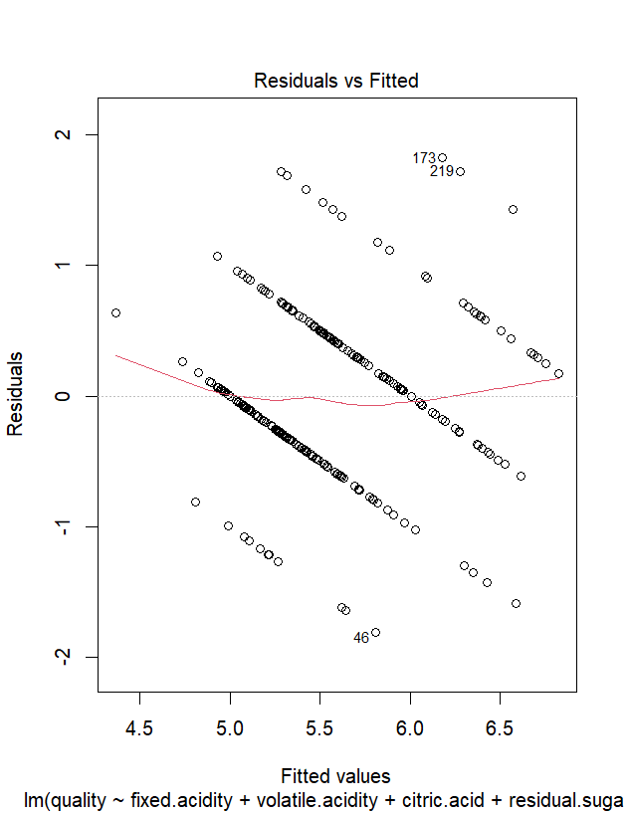

Then, to test for normality, we checked the Q-Q plot on both the full and reduced models (images 13 & 14 respectively). We checked the normality assumption before and after doing the selection model just to see if there was any effect. What we found was that there wasn’t much of a difference between them. Both graphs looked mostly linear with slight variations on both ends, but nothing strong enough for us to feel like we needed to transform or model to satisfy the assumption any better.
Image 13 Image 14
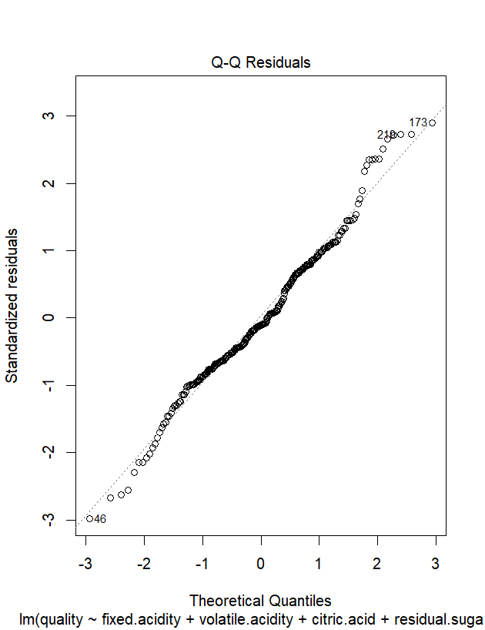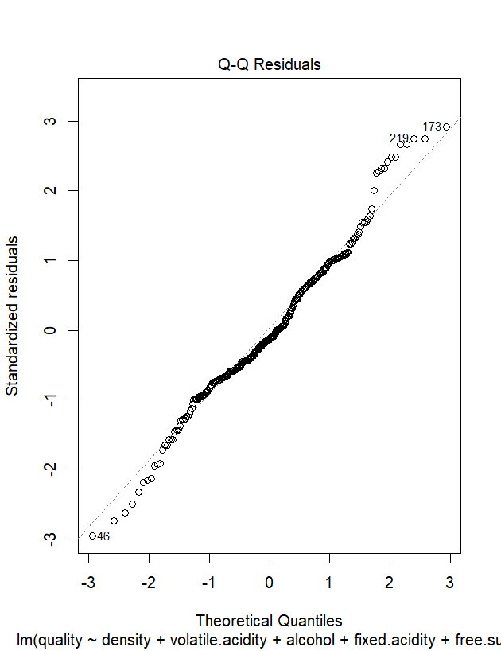
Since we had decided that our model met all the necessary assumptions, our last check was for outliers. In order to identify any potential areas of interest, we checked Cook’s distance, leverage, and jackknife residuals. Using Cook’s method, we checked the 5 largest data points rather than all 300 observations as it would have been very tedious to look at all values, other than the fact that we were assuming that most our observations were normal due to our findings above. With this test, outliers would be identified by having a value greater than 1. Looking at image15, one could notice that there weren’t any outliers identified in our data.

Image 15
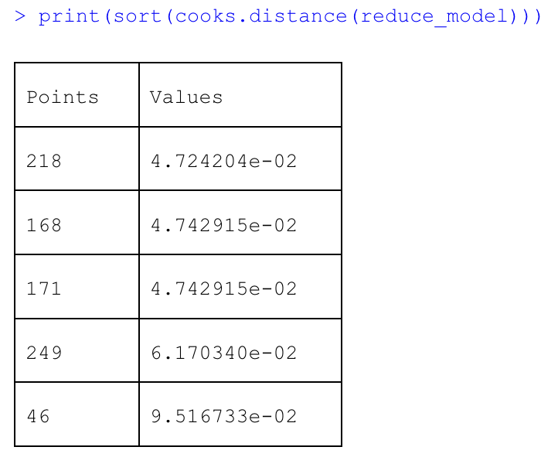
Next, we checked leverage. With this method of outlier identification, we needed values to be greater than ${2(k+1)}/n$ to be considered areas of high influence. With our data set, this value was found to be 0.06. As image 16 shows, 19 observations were found to be violating this value (highlighted values within image 16). To further test if these values would truly be an issue, we ran one final test for outliers using jackknife residuals.
Image 16
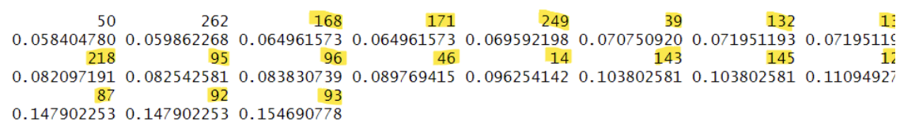
With this test, where values lay in a number line (whether positive or negative) didn’t matter, only whether the absolute values were greater than the appointed threshold was of interest. This value was identified to be 1.968 in our dataset. Looking at image 17, it was found that 21 points were considered to have high influence (highlighted values within image 17).

Image 17
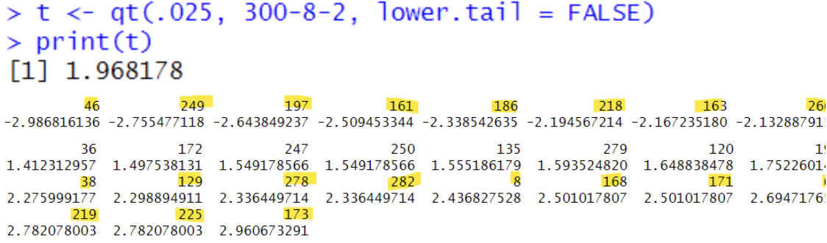
While some observations were found to be potential outliers within the last two tests we ran for outliers, considering the fact that no values showed up in our Cook’s distance test, we ultimately decided these observations didn’t have to removed. We decided that keeping them in our model didn’t worsen our data and deleting them wouldn’t better it.
The last test left for us to run was a test of collinearity. To test for this, we checked the VIF values of the partial model (image 18). This measured how much variance the regression coefficients increased due to any underlying collinearity. If values were found to be greater than 10, they would be in violation. Thankfully, this was not the case, so no values needed to be removed.
Image 18
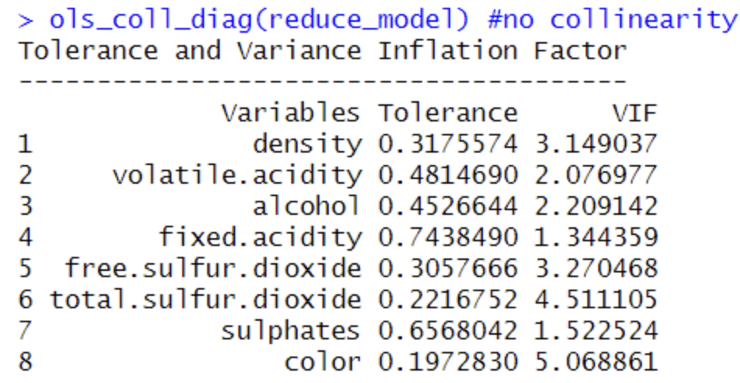
Due to a dummy variable existing in our data set, wine color, we wanted to run a test for coincidence and possibly parallelism, depending on the results from the first test. To test for coincidence between red and white wine observations, we ran the R script below.
full_modeltcp <- lm(quality ~ fixed.acidity + volatile.acidity + free.sulfur.dioxide + total.sulfur.dioxide + density + alcohol + sulphates + color + fixed.acidity*color + volatile.acidity*color + free.sulfur.dioxide*color + total.sulfur.dioxide*color + density*color + alcohol*color + sulphates*color)

reduced_modeltc <- lm(quality ~ fixed.acidity + volatile.acidity + free.sulfur.dioxide + total.sulfur.dioxide + density + alcohol + sulphates)

anova(reduced_modeltc, full_modeltcp)

From this, we were able to make conclusions using the given output in image 19 and create an interpretation before decided what do to moving forward.
Image 19
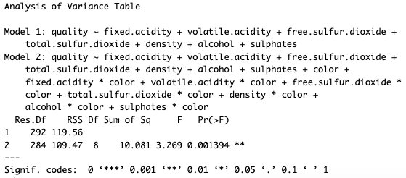
What we came up with was the following:
H₀: $β_{8,…,15}$ = 0
H_{a}: at least 1 $β_{i}$ (i = 8,..., 15) $≠$0
F = 3.269
P-value = 0.0014
Conclusion: At $α=0.05$, we reject H₀ and conclude lines between white wine and red wine aren’t coincidence. Because this test for coincidence is significant, we could proceed to test for parallelism. To run this test, we ran the R script below.
full_modeltcp <- lm(quality ~ fixed.acidity + volatile.acidity + free.sulfur.dioxide + total.sulfur.dioxide + density + alcohol + sulphates + color + fixed.acidity*color + volatile.acidity*color + free.sulfur.dioxide*color + total.sulfur.dioxide*color + density*color + alcohol*color + sulphates*color)

reduced_modeltp <- lm(quality ~ fixed.acidity + volatile.acidity + free.sulfur.dioxide + total.sulfur.dioxide + density + alcohol + sulphates + color)

anova(reduced_modeltp, full_modeltcp)

From this, we were able to make conclusions using the given output in image 20 and create an interpretation.
Image 20
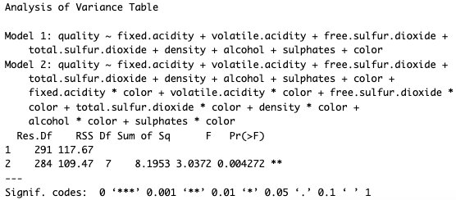
What we came up with was the following:
H₀: $β_{9,…,15}$ = 0
H_{a}: at least 1 $β_{i}$ (i = 9,..., 15) $≠$0

F = 3.0372
P-value = .0043
Conclusion: At $α=0.05$, we reject H₀ and conclude the lines between red wine and white wine aren’t parallel. This means that wine quality does differ for color. Thus, the relationship between the predictors and quality changes depending on the type of wine.
The final model we were left with after all these tests is shown below. Interpretations of how exactly each of these variables affect wine quality will be explored.

Quality = Density + Volatile acidity + Alcohol + Fixed.acidity + Free.sulfur.dioxide + Total.sulfur.dioxide + Color + Sulphates

Density saw a 0.01 unit decrease that lead to a 0.57 unit decrease in wine quality. The range we found was very small, only spreading 0.0226 values from 0.9912 to 1.0138${g/cm}^{3}$ (Budziak-Wieczorek). For volatile acidity, a 1 unit decrease was found to decrease wine quality by 0.864. Total sulfur dioxides (which had previously been merged with free sulfur dioxides) was found to also decrease quality by 0.018 for every 1 unit increase. These variables should be carefully controlled by wine makers as any increase of them could lead to lower sales due to a subsequent decrease in quality.
The rest of our variables caused an increase in quality and should be controlled appropriately as well. For every 1 unit increase in alcohol, a 0.185 increase in quality was observed. for fixed acidity, a 1 unit increase also increased quality by 0.055 units. Sulphates increased quality by 0.282 units for every 1 unit it increased. And most interestingly, white wine was found to found to have an average 0.357 units of quality higher than red wine. This was interpreted by us to mean that the Vinho Verde company should also focus on producing more white wine over red wine.

While we didn’t run into many limitations throughout our project, something that is important to note is that our findings aren’t universal for all wines. Only Vinho Verde wines were used in this study – and only their red and white wine variety. This leads for any general assumptions to be inappropriate. Improvements were also suggested by the professor during our final presentation into how we can make our findings more accurate. These suggestions were taken into serious consideration and then implemented. These included fixing our parallelism and linearity tests.

Overall, this project proved to really strengthen both our presentation and teamwork skills. It was a challenge to divide work and keep up a schedule, but we persevered and completed our work. We were also able to learn how to code in R and interpret our findings in an accurate model. Before we had started this class, we were all fairly unpolished in our statistical skills. Through this class, we were able to strengthen them and explore the world of statistics further.

Our research question was to see which variables from the original dataset influenced wine quality the most. In the end, forward selection gave us 8 variables. While some are best to keep as low as possible in order to get the highest possible value for quality, others are best kept in high quantities. While we can’t make assumptions for all wines across the board, this can help increase the marketability of all Vinho Verde wines.

We, the project team members, certify that below is an accurate account of the percentage of effort contributed by each team member in the project and report.

Project Team Member | Percentage of Total Effort
Alexandra Nelson | 25%
Daisy Hernandez Gonzalez | 25%
Dao Nguyen | 25%
Joymelyn Lyka Garde | 25%
Works Cited
“Wine Quality.” UCI Machine Learning Repository, archive.ics.uci.edu/dataset/186/wine+quality. Accessed 8 Apr. 2024.
Budziak-Wieczorek, Iwona, et al. “Evaluation of the Quality of Selected White and Red Wines Produced from Moravia Region of Czech Republic Using Physicochemical Analysis, FTIR Infrared Spectroscopy and Chemometric Techniques.” Molecules (Basel, Switzerland), U.S. National Library of Medicine, 29 Aug. 2023, www.ncbi.nlm.nih.gov/pmc/articles/PMC10489813/#:~:text=This%20means%20that%20the%20density,to%201.0138%20g%2Fcm3.

